Single Author (Notizen)
(Der Text beginnt auf Seite 4)
Ziel
- Verfälschen die Medien, die ECB Positionen bezüglich der Inflation?
- Hat der Unterschied zwischen dem ECB Sentiment und dem News Sentiment einen Einfluss auf das Inflations Forecasting privater/professioneller Haushalte?
Bisher umgesetzt
- Datensammlung
  - Mediendaten von Paper mit Mariia und Kai
  - Bereninugn der ECB press conferences

- Sentimentanalyse
  - Erstellung eines Trainingdatensatzes für:
    - News: Sentiment und Richtung für Inflation
    - ECB: Sentiment, Monetary stand und Richtung für Inflation an Anlehnung an Picault und Renault’s Paper
  - Benutzung von BERT
  - Kopie des Lexicon Ansatzes von Picault und Renault
- Analyse
  - Vergleich der erstellten Indizes mit den relevanten Zeitreihen
  - Kombination von News Sentiment und New Direction führt zu besserem Index
Bisherige Ergebnisse
- Replikation der Ergebnisse von Picault und Renault bezüglich der ECB Indizes
- Starke Korrelation zwischen meinen Newsindizes und der Inflationsentwicklung
Noch fehlend
- Erstellung eines dritten Ansatzes für Text Classification
  - Lexicon Ansatz basierend auf Seed words
  - Nutztung von Tris Ansatz um Lexicon mit Word Embedding zu generieren
Derzeitige Probleme
- Eigener methodischer Ansatz fehlt
- Ich bin mir nicht sicher, wie ich von den bisherigen Ergebnissen ausgehend meine Fragestellung beantworten soll, weil
  - Medienindex korreliert stärker mit Inflation als ECB Index und bildet die Inflation über den gesamten Zeitraum besser ab.
  - Kein Zugang zu professionellen Inflationsforecast auf deutscher Ebene
Nächste Schritte
- Finja und Timo fragen
- Mariia fragen
- Kai bisherige Ergebnisse vorstellen
Langfristige Schritte

Alternative Idee
- Erstellung von Seed based Lexicas um das Sentiment und die Richtung im Bezug auf unterschiedliche Aspekte zu klassifizieren
  - Auf welche Form der News regieren Zinsenschteidungen? (Zu nah an Picault und Renault?)
  - Beantwortung der Ausgangfrage basierende auf zusätzlichen Aspekten

Abstract (N) (fehlt)
Introduktion (J) (Part 1 fertig)
Related Literature (V) (fehlt)
Methode
- Data (N) (News Teil fehlt)
- Lexicon (J) (Formel fehlt)
- BERT (J) (Formel fehlt)
Analyse
- Deskriptive Part (J) (in Ansätzen)
- Regression Part (V) (nach Rat fragen)
- Interpretation (N)
Conclusion (N)

1. (Placeholder)
1.1 Introduction
(Hook missing)
A branch of the literature focuses on central bank communication, i.e., the information provided by central banks to the general public. In recent years, text-based methods like text classification or topic modeling were employed to analyze the connection between different variables of interest like financial variables or future monetary decisions of the central bank and central bank communication. For example, Picault et. al (2017) show that ECB press statements can be used to predict future ECB monetary decisions while Shapiro and Wilson 2022 use internal Fed meetings to estimate their inflation target. (Give more examples?)
A subbranch of this literature focuses on the connection between inflation expectations and central bank communication. Picault et. al (2022) and Hubert (2017) investigate how the reporting about the ECB in the media can be used to predict financial market inflation expectations. Lamla and Lein (2014) show that media coverage of inflation can be used to explain the error in household inflation expectations. (Give more examples)
Most of the literature focuses on the direct link between central bank communication and financial variables. However, Hayo and Neuenkirch (2015) and Picault et. al (2022) note that the perception of financial markets is simultaneously influenced by the central bank communication and the media coverage of the corresponding events and central bank communication. Following this line of thought I assume that the media coverage of central bank communication acts as an intermediate channel(?) between the central bank and the households. The households consume the news about the central bank communication rather than the original central bank communication.
This view gets supported by Kumar (2015) who shows that New Zealand households rarely consume direct communication of the New Zealand central bank. (Give more examples)
I combine these two branches of literature and investigate the influence of media coverage in German newspapers of ECB press conferences on households’ inflation expectation accuracy.
Firstly, I investigate if the information given in regard to inflation in media coverage deviates from the inflation information in the original press conferences by the ECB which would introduce a bias and could potentially influence how the general public perceives monetary policy decisions. Secondly, I investigate how media coverage and central bank communication can be used to explain the household’s inflation expectation errors.
This paper, is to my knowledge, the first paper which explicitly investigates the link between (quantified) ECB communication and news coverage in regard to household inflation expectations. Furthermore, it contributes to the literature by demonstrating how the news about inflation deviates from the corresponding ECB communication, allowing to it for central banks to better understand how their communication is perceived by the general public and explains the channel through which the general public reacts to ECB communication.
To quantify the textual data from the ECB communication and the news coverage I apply several supervised (2-3) prominent approaches from the literature and applies them to the data. Furthermore, this paper applies a semi supervised approach that does only rely on a few pre-selected words instead of a full training dataset.
(NOTE: I have not yet implemented the last approach, and I am not sure if it would be worth it. This approach is underused in the current economic literature due to its relative novelty and complexity. It could be interesting to implement this approach and provide the resulting lexicons. Of course, I cannot be sure that this approach even produces feasible results, and it could be not worth the time.
(NOTE 2: I could maybe ask Tri and take his method instead. It is still supervised, but I could slightly modify it to produce a lexicon. It would most likely be a improvement over Picault et. al (2017) due to the word embeddings)
(NOTE 3: Before I can describe the model which I use for the second part, I need to certain what exactly I want to regress and how to do it.)
(Some Empirical Results as teaser)
1.2 Related Literature
(Here I further describe the different branches of literature related to my paper and how my paper fits in the current literature. However, I first need to finish the second part of my paper.)
2. Data
My dataset consists of two different parts. The textual data from the ECB and the Media and the quantitative data regarding inflation and inflation expectations. In (SECTION) I describe how I quantify the textual data.
2.1 Textual Data
I collected two separate datasets for the textual analysis, one for the ECB communication and one for the media news.
The ECB’s main channel for communication to the media are their press conferences (CITE?). The press conference takes place after the ECB’s Governing Council took their monetary policy decision every six weeks . I collected ECB press conference from 2000 until 2022 with a webscrapper from the official ECB website (footnote in Latex to website). I discarded the Q&A section and all sections which carry no significance, like greetings and acknowledgments, leaving only the introductory statements.
(News dataset description. Before I can do the description of the news dataset, I need to know which data I am allowed to use)
(Important: News dataset is in German, ECB dataset in English)
To filter out any data that is not relevant for inflation, I only included sentences which contain the word inflation and synonyms of inflation like “Preisteigerung” (price increase). Furthermore, I filtered out all purely financial news, like reporting of stock movements or business news (better word?).
(Provide list of synonyms somewhere ? Not sure if this is the best way to select inflation related sentences. Maybe some kind of topic modeling would be better suited.)
To reduce the dimensionality of the data I apply several pre-processing steps to the two datasets which are commonly used in the literature: Lowercasing, removing punctuation, and removing so called stopwords (e.g., and, but, or) which carry no information and removing numbers.
(I only do these steps for the lexicon approaches)
(NOTE: Currently the news dataset includes all inflation related sentences without differentiating between ECB and non ECB related new. I probably need to change that, but how do I do that and makes that even sense?)
2.2 Quantitative Data
For the inflation I use the quarterly year-on-year HCPI growth rate for the Eurozone collected from the Eurostat database.
(Quarter-on-quarter instead?)
(Right now, I use the FRED data, need to change that.)
The ECB surveys each quarter professional forecasters regarding their annual HICP expectations and provides the results to the general public. The survey ranges from the first quarter of 1999 up until the last quarter of 2022. I use the point forecast averaged over all responds for the current (should I better use the future?) annual HIPC forecast as my professional inflation forecast.
For the consumer (or household, which is better?) inflation the results from the Consumer Expectations Survey which collects information about households inflation expectations by asking them if they expect that the prices increase, remain unchanged or decrease in the next 12 months.
(Note: The inflation expectations for Germany are unfortunately qualitative. I would need to follow Lamla (2014) and transform the data to quantitative data. Alternatively I could use the inflation expectations for the aggregated Eurozone)
(I take the “balanced” expectations. How do describe? It should not be too long)
3. Method – Text Classification
Method Measuring the central bank communication and news coverage
In the following section I will lay out how I quantified the ECB communication and news. I do this by separating my dataset into individual sentences and then classify each sentence according to predefined categories.
Two main approaches are mostly used for text classification, the lexicon-based approach, and the machine learning approach. For the lexicon approach a text is classified by taking a list of words, the lexicon, where each word belongs to one of the desired categories, such as “good” for positive sentiment or “bad” for negative sentiment. The text is classified by counting the occurrence of each of these word in the text. The lexicon approach can be modified by adding linguistic rules like negations (CITE?).
The machine learning text classification approach classifies a text based on supervised or semi-supervised models to a given category. In recent years, deep-learning models have been widely used for text classification.
(Continue this part with some examples)
The ECB press conferences are classified into three categories where each category consists of three classes. The first two categories are taken from Picault et. al (2017). The first category describes the monetary stance expressed as monetary hawkish, monetary neutral or monetary dovish. The second category describes the economic outlook either as positive, neutral, or negative. I add a third class which describes the inflation outlook either as increasing, steady or decreasing. This third class allows for a direct comparison of the inflation expectations communicated in the ECB press conference to the inflation expectations expressed by the news media.
The News articles are classified into two categories where each category consists of three classes. The first category describes the economic outlook expressed in the news which can be either positive, neutral, or negative. The second category describes the inflation outlook which can be either increasing, neutral or decreasing.
Training Dataset
In the next section I will use supervised models to classify my data into several categories. I trained the models with two trainings dataset which I created, one for the news and one for the ECB press conference. I manually classified 3000 randomly drawn sentences from the ECB press conferences according to the three categories where each sentence was labeled with one of the three classes for each category. Similarly, 3000 sentence were randomly drawn from the news corpus and labeled based on the two categories. The sentences were then used to classify the remaining sentences from my dataset with the method described in the next two sections.
(Is it obvious enough why I used two different training datasets? I should further describe my annotation scheme in the appendix and give some examples.)
3.1 Method – Lexicon
The simple implementation and transparency of Lexicon-based sentiment classification has made it widely used in the literature Shapiro (2020), (CITE), (CITE), (CITE), (CITE). Several lexicons exist for sentiment classification (CITE), (CITE), (CITE). However, these lexicons are not optimized for ECB communication or economic news. (FIND EXAMPLE). Picault et. al (2017) solve this problem by manually classifying each sentence in the ECB press conference based on their monetary stance and economic outlook. The classified sentences are then used to build a lexicon from the word used in the press conferences to classify the monetary stance and economic outlook of a press conference. I implement their approach with my own training dataset. The resulting lexicon is then used to classify each sentence in the ECB press conference for each of the three categories with the formula:
(FORMULA IN LATEX, same as in Picault et. al (2017) or any other similar papers. It’s just positive words – negative words divided by all words,)
with the class score s, the press conference i, the category c, the class j and the number of word occurrences n. A final score for each category in each press conference is calculated by taking the averaging the category score over all sentences from the corresponding press conference.
I slightly deviate from Picault et. al (2017) by first calculating the category score for each sentence instead of directly calculating score for the full press conference. My approach however is in line with most of the literature (Example from book or paper?).
Similiar to the press conferences, I calculate the category score for the news. First I create a lexicon for each of the two categories with the method from Picault et. al (2017). The category score for each news sentence in my dataset is calculated with (EQ). A monthly category score is calculated by averaging the sentence score for each month.
I further deviate from Picault et. al (2017) or similar papers like Marozzi (2021) (Still WP, and he at least uses valence shifters) by applying several linguistic rules to take grammatical(?) relations into account.
(I added negation handling and I will add some more rules. Not sure if I should describe that in the main text or in the appendix. The rules are using POS tags to identify negative and positive phrases, e.g., a negative adjective in front of a positive noun results in a negative phrase instead of a neutral phrase.
3.2 Method – Supervised
The main drawback of lexicon-based text classification is that this approach is not able to take complex grammatical context into consideration. The addition of (syntactical?) rules like negation handling can help to alleviate this shortcoming. However, fixed rules are not able to take the full grammatical nuance of a text into account. Therefore, supervised text classification methods which can consider the full grammatical context of a text became popular in recent years. One of the most popular of these types of models is BERT by Devlin et. al (2019).
(Should I describe BERT in detail? Some papers, especially in economics, just skip it and directly refer to the original paper)
Supervised text classification is less used in the economic literature but it became increasingly popular in the last years. (CITE EXAMPLES)
The class labels are expressed as 1 for the increasing or positive classes, 0 for the neutral classes and -1 for the decreasing or negative classes. The final category score for a press conference is then calculated by with the following formula.
(Formula in Latex, (positive sentences – negative sentences)/(positive sentences + neutral sentences + negative sentences), CITE)
Doing this for each press conference and each of the three categories results in three different indices.
The same thing is done with the classified sentences from news for each quarter to get a time series for sentiment and inflation direction. I combine these two time series into one by multiplying them. I call the resulting time series inflation news index (INI).
3.3 Method – Semi-Supervised
(Not yet sure if I should try to implement that. Even two different approaches could already be too much, especially if I use Tries approach for the lexicon classification.)
Analysis
(NOTE: In the following I only use the results from the BERT model, because it tends to produce more plausible results. I will do a detailed comparison between lexicon and BERT in the Appendix. For the next steps I only need one approach.)
Descriptive Part (Indices) (Placeholder title)
News Index
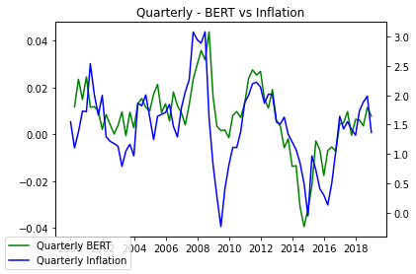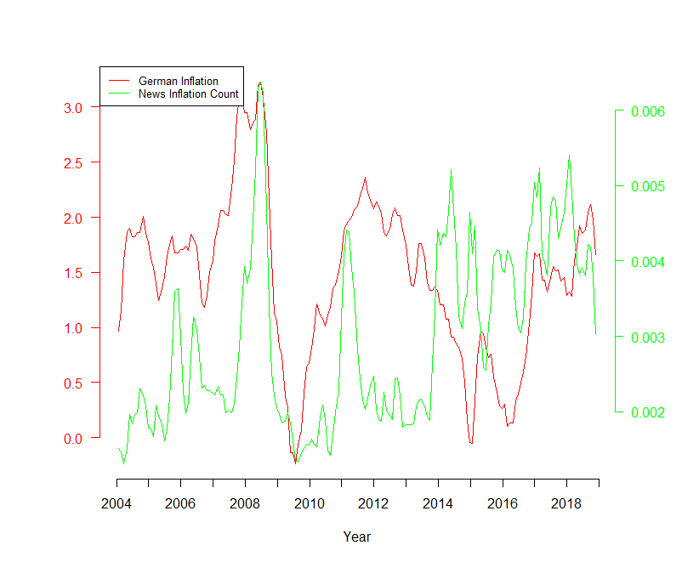
(FIG) depicts the INI together with the quarterly GERMAN CPI growth rate from 2000 to 2018. The index strongly correlates with the inflation (correlation value) with the noticeable exception of the inflation decrease during the Great Recession which was not fully depicted by the INI. The inflation dip during the Great Recession was accompanied by a strong decrease in inflation related news. In contrast, the low inflation phase in 2015/2016 was marked by an elevated level number of corresponding news and a strong decrease of the INI.
(Is there more to say? Should I search for reasons why the INI behaves strangely during the Great Recession? Any ideas?)
(NOTE: I plot the 3-month rolling average of the monthly data for better visibility)
(NOTE: Should I create a table where I document all important correlations, means, sd usw, or should I just write it in the text directly if important?)
ECB Indices
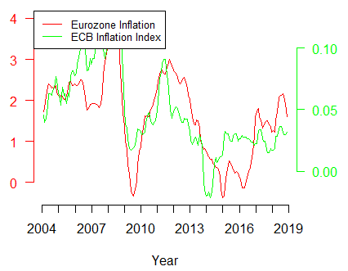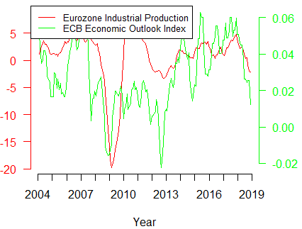

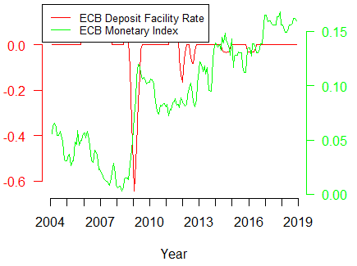

(FIG) depicts the ECB inflation index in green next to household and professional inflation expectations.
(Note: The German household inflation expectations are normalized)
(Repeat same step for ECB index – Outlook vs Eurozone industrial production, Monetary – vs interest rate, Inflation – Eurozone inflation)
(NOTE: The results are quite similar to Picault et. al (2017) and Marozzi (2021), which is reassuring, but I only add 4 more years to the dataset. Therefore, my approach adds little new information regarding the ECB indices. I should therefore not focus on the ECB Indizes)
Difference between ECB and News Indices (Placeholder title)
(Is an extra subsection for the comparison of ECB and News Indices smart?)
Inflation Expectations (Placeholder title) 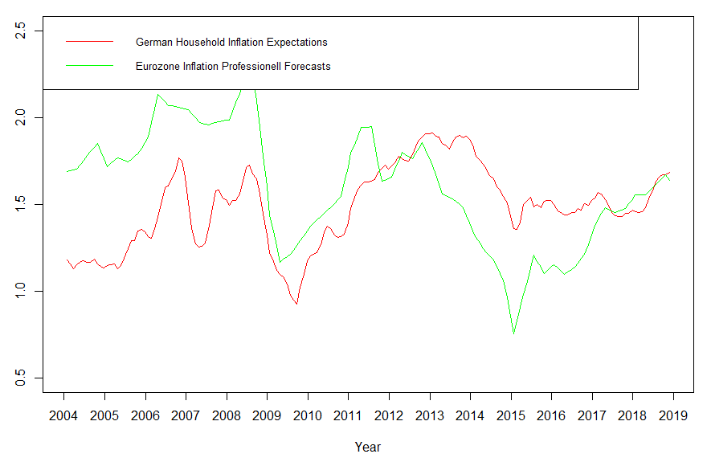
(Rule based forecast for high differences in German household expt)
The inflation expectation error of household is in the literature typically defined as the difference between household inflation expectations and professional inflation expectations (CITE) (CITE). To measure the error, I use the EU household inflation expectation described in and the professional inflation forecasts for the Eurozone described in (SECTION 2). My interest lies in the deviation between the household inflation expectations from the optimal forecasts. Therefore, I follow Lamla (2014) and calculate the household forecast errors as the difference between the household inflation expectations and professional inflation forecast for the Eurozone in the coming 12 months. I deviate from Lamla (2014) by taking the non-absolute error. (CITE) and (CITE) show that households react differently to news regarding high and low inflation.
(Lamla (2014) uses the absolute error. However, wouldn't it make more sense to take the non-absolute error in case of asymmetric behavior? Some papers indicate asymmetric behavior when it comes to inflation in news. Even if the behavior is symmetric, it could still be interesting to communicate that)
(How to continue from here? I probaly should define difference metric between the ECB inflation index and the news inflation index. Lamla (2014) simply do some OLS regression (Expecation gap on media indices. However, he also created a theorie which ties his regression together and lets him explain his results. I could try to modify his theory or come up with something on my own. Would that make sense???)
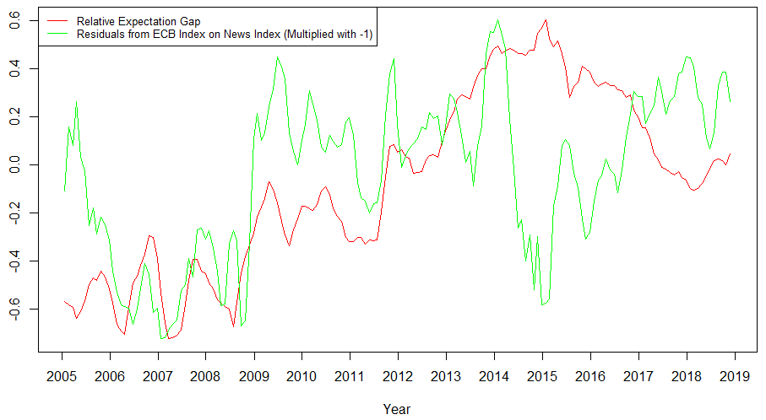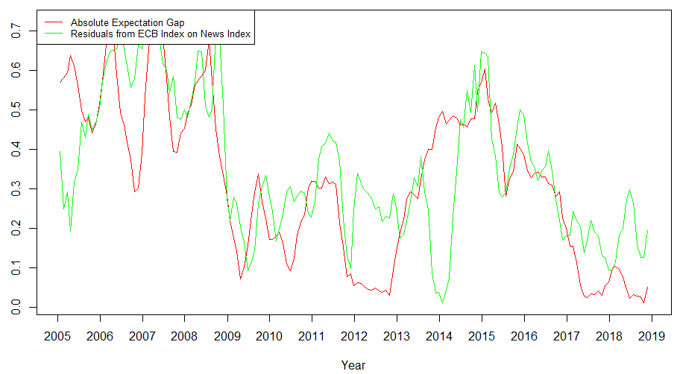
(Regress Inflation on Media, Regress Inflation on ECB, take difference)

- Try out different types of inflation and take the one with the highest correlations
- Plot ECB Economic Index together with EU professional GDP forecast
- Plot ECB Inflation Index together with EU professional Inflation forecast
- Recessionen in einigen Plots grau einfärben
- ECB Index bis ans Jahresende plotten
- Am Sonntag die Forecasting Daten von Reuters über Datastream abgreifen
- E-Mail senden, um abzuschecken, ob ich die Daten auch für mein Paper verwenden darf

